Project Design Phase
Solution Architecture

Date | 15 July 2026
Team ID
Project Name | Book a Doctor – Online Doctor Appointment Booking System
Team Members | Anvesh Gudipalli (Team Lead), Kunasani Sravani, Parisi Rahul, Seelam Rukmini, Geethika Viri Mahitha Singidi
Maximum Marks | 4 Marks

Solution Architecture:
Solution architecture is a complex process – with many sub-processes – that bridges the gap between business problems and technology solutions. Its goals are to:
- Find the best tech solution to solve existing business problems.
- Describe the structure, characteristics, behavior, and other aspects of the software to project stakeholders.
- Define features, development phases, and solution requirements.
- Provide specifications according to which the solution is defined, managed, and delivered.

Example - Solution Architecture Diagram:


Figure 1: Architecture and data flow of the voice patient diary sample application
Reference: https://aws.amazon.com/blogs/industries/voice-applications-in-clinical-research-powered-by-ai-on-aws-part-1-architecture-and-design-considerations/

Proposed Solution Architecture Diagram – Book a Doctor:
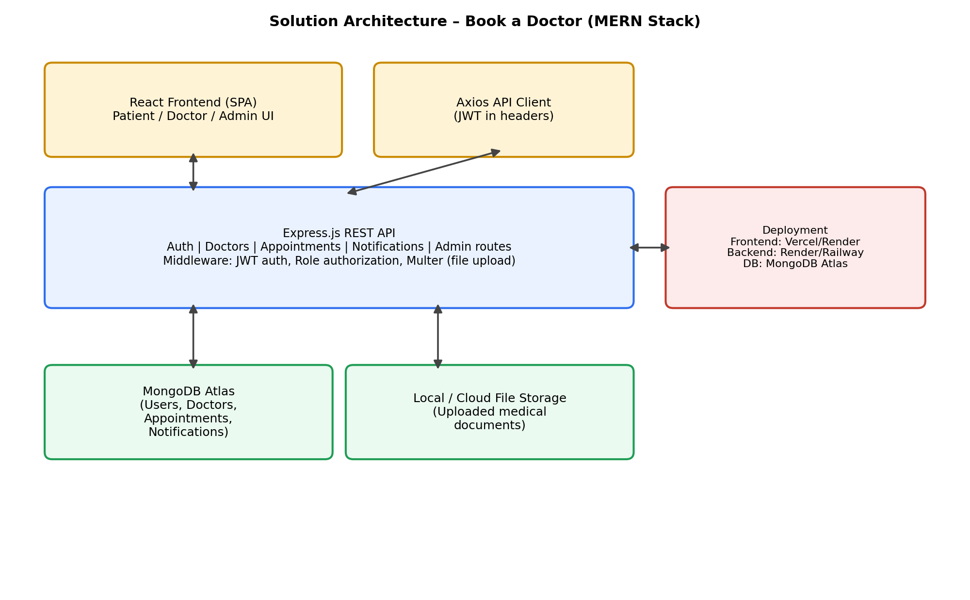
Figure: 3-tier MERN architecture — React frontend, Express.js REST API with JWT auth & role-based middleware, and MongoDB Atlas data layer, with local/cloud storage for uploaded documents.
Architecture Components:
Layer | Component | Responsibility
Presentation | React SPA (Patient/Doctor/Admin UI) | Role-based dashboards, doctor search, booking forms, document upload UI
Presentation | Axios API client + AuthContext | Attaches JWT to requests, manages login/session state, protects routes
Application | Express.js REST API | Exposes /api/auth, /api/doctors, /api/appointments, /api/notifications, /api/admin
Application | Auth & Role Middleware | Verifies JWT (protect) and restricts endpoints by role (authorize)
Application | Multer Upload Middleware | Handles multipart file uploads for patient medical documents
Data | MongoDB Atlas (Mongoose models) | Stores Users, Doctors, Appointments, Notifications collections
Data | File Storage | Stores uploaded document files referenced by Appointment records
Deployment | Cloud Hosting | Frontend on Vercel/Render, backend on Render/Railway, DB on MongoDB Atlas

